WEEK:03 ROLL NO:230701304

PROGRAM 1:

import java.util.Scanner;

import java.io.\*;

class original{

void count(){

Scanner scan=new Scanner(System.in);

int n=scan.nextInt();

int a[]=new int[n];

for(int i=0;i<n;i++){

a[i]=scan.nextInt();

}

for(int i=0;i<n;i++){

for(int j=i+1;j<n;j++){

if(a[i]>a[j]){

int temp=a[i];

a[i]=a[j];

a[j]=temp;

}

}

}

int og=scan.nextInt();

int flag=0;

for(int i=0;i<n;i++){

if(og==a[i]){

int ans=og\*2;

og=ans;

flag=1;

}

}

if(flag==1)

System.out.println(og);

else

System.out.println(-1);

}

}

public class zero extends original{

public static void main(String[] args){

original o=new original();

o.count();

}

}

OUTPUT:

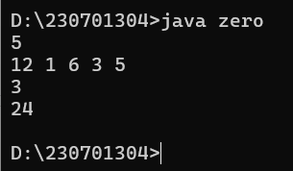

PROGRAM 2:

import java.util.Scanner;

import java.io.\*;

class original{

void cal(){

Scanner scan=new Scanner(System.in);

int n=scan.nextInt();

int a[]=new int[n];

for(int i=0;i<n;i++){

a[i]=scan.nextInt();

}

int min=a[0],index=0;

int max=a[index+1];

for(int i=1;i<n-1;i++){

if(min>a[i+1]){

min=a[i];

index=i;

}

}

for(int i=index+1;i<n;i++){

if(max<a[i]){

max=a[i];

}

}

System.out.println(max-min);

}

}

public class price extends original{

public static void main(String[] args){

price p= new price();

p.cal();

}

}

OUTPUT:

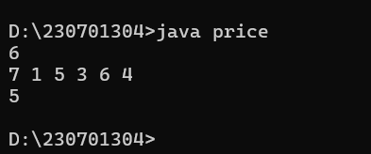

PROGRAM 3:

import java.util.Scanner;

import java.io.\*;

class array{

void zero(){

Scanner scan=new Scanner(System.in);

int n=scan.nextInt();

int a[]=new int[n];

for(int i=0;i<n;i++){

a[i]=scan.nextInt();

}

for(int i=0;i<n;i++){

for(int j=i+1;j<n;j++){

if(a[i]>a[j]){

int temp=a[i];

a[i]=a[j];

a[j]=temp;

}

}

}

for(int i=0;i<a.length;i++){

System.out.print(a[i]+" ");

}

}

}

public class print extends array{

public static void main(String[] args){

array ar=new array();

ar.zero();

}

}

OUTPUT:

